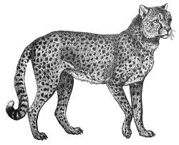
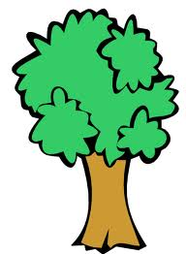
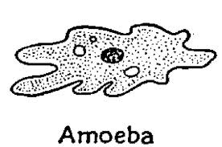
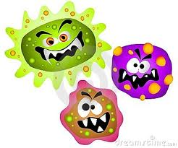
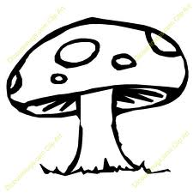
“The Six Kingdoms of Life”
Brochure

Name: ____________________________________ Date assigned: ___________________________
Parent Signature: ____________________________ Date due: _______________________________

Objective: You will demonstrate your knowledge of the Six Kingdoms by gathering information from your science journal, class notes, science textbook/workbook, and websites that are on my teacher website at www.mrsmaschas.weebly.org . The information that you collect will be used to create a brochure about “The Six Kingdoms of Life” in which scientists classify within our world.

Your brochure will be organized as follows:
1. Making the Brochure: The brochure will be made out of one big piece of paper provided from the teacher. Fold the paper into thirds.
2. Front Cover of Brochure: Your cover should have a picture or pictures: either clipart or drawn. Also, include an appropriate and creative title about The Six Kingdoms of Life. Your name should be written in the bottom right corner of the cover.
3. Inside the Brochure: Inside your brochure, you should have one section for each of the six kingdoms.

The Six Kingdoms are: (Bacteria) Eubacteria Kingdom, (Bacteria) Archaebacteria Kingdom, Protist Kingdom, Fungi Kingdom, Plant Kingdom, and Animal Kingdom.

Make sure to use front and back of the paper. Since, there will only be five open sections left in the brochure,
you should place both the Eubacteria Kingdom and Archaebacteria Kingdom in the same section titling this section “Bacteria Kingdom: divided into two kingdoms”.
You must include the following information for each of the six kingdom sections:
- Title the section for each specific kingdom. (Remember each kingdom will have its own page, except the two bacteria kingdoms.)

- Are the organisms unicellular (single-celled) or multicellular (many-celled) or both?

- Are they prokaryotic (lacks a true nucleus) or eukaryotic (cells that contain a true nucleus with genetic material (chromosomes with your DNA) within the nucleus)?

- Do they make their own food (autotrophs) or get it from other organisms (heterotrophs)?

- Include pictures and/or diagrams of organisms within each kingdom

- Make sure you include other important characteristics and definitions for each individual kingdom:
Include all important facts from your textbook for each kingdom:
One example: The Plant Kingdom must also include definitions about vascular, nonvascular plants, angiosperms, and gymnosperms.
One example: The Animal Kingdom must also include definitions about vertebrates and invertebrates and what animals are found in each.

